# Project Development Phase

**Delivery of Sprint-2**

|  |  |
| --- | --- |
| **Date** | 04 NOV 2022 |
| **Team ID** | PNT2022TMID39750 |
| **Project Name** | Analytics for Hospitals' Health-Care Data |

**Project Development Phase:**

**Sprint-1:**

* Data Collection
* Data Preparation

**Sprint-2:**

* Data Exploration

**Sprint-3:**

* Dashboard Creation

**Sprint-4:**

* Report Creation
* Story Creation

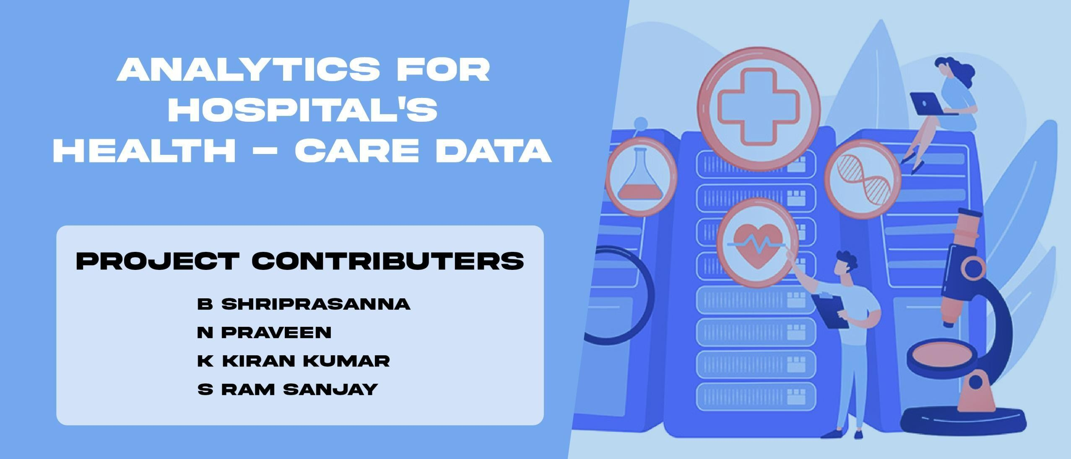

TEAM ID : PNT2022TMID39750

# Sprint-2:

**Data Exploration:**

* **Department compared to Hospital_region_code**
* **Ward_Facility_Code for City_Code_Patient hierarchy**
* **case_id by patientid**
* **Visitors with Patient by Type of Admission**
* **Ward_Type colored by Department sized by Department**
* **Hospital_region_code for Hospital_region_code regions**
* **City_Code_Hospital by City_Code_Hospital**
* **Type of Admission by Department colored by Department**
* **City_Code_Hospital by Department**
* **Ward_Type for Ward_Facility_Code**

Department compared to Hospital_region_code:

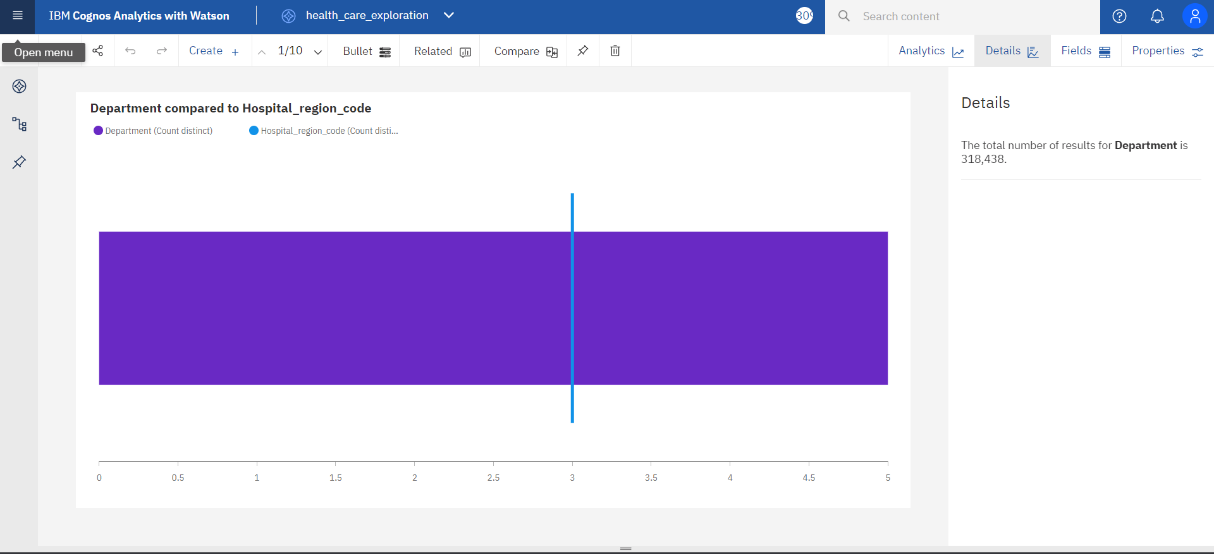

Ward_Facility_Code for City_Code_Patient hierarchy:

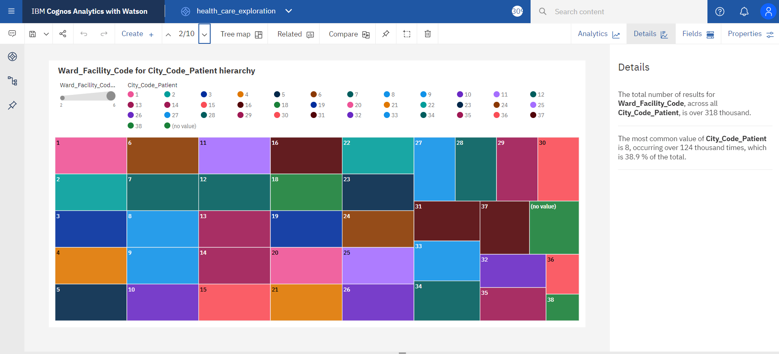

## case_id by patientid:

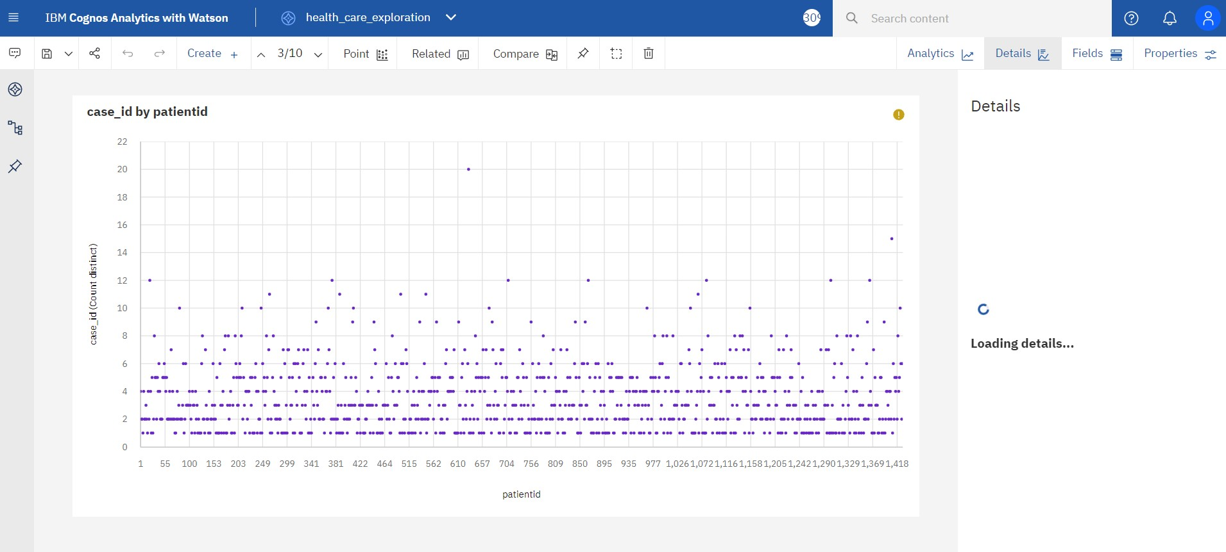

Visitors with Patient by Type of Admission:

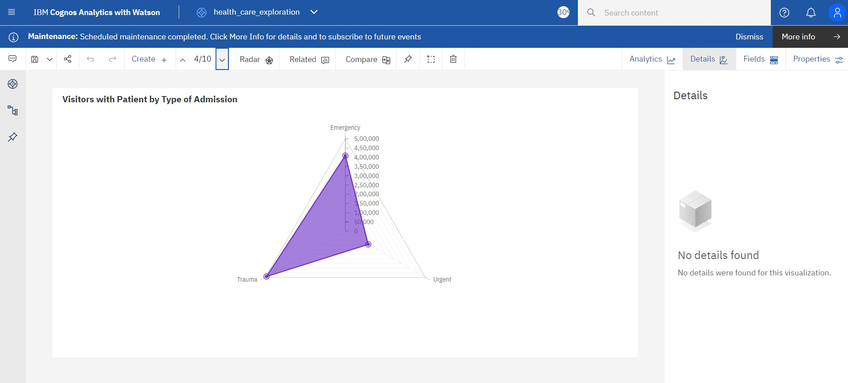

Ward_Type colored by Department sized by Department:

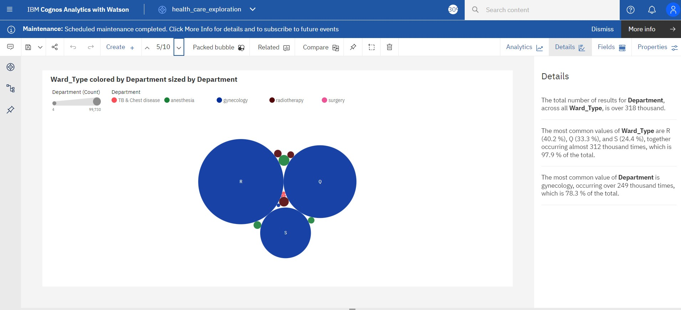

Hospital_region_code for Hospital_region_code regions:

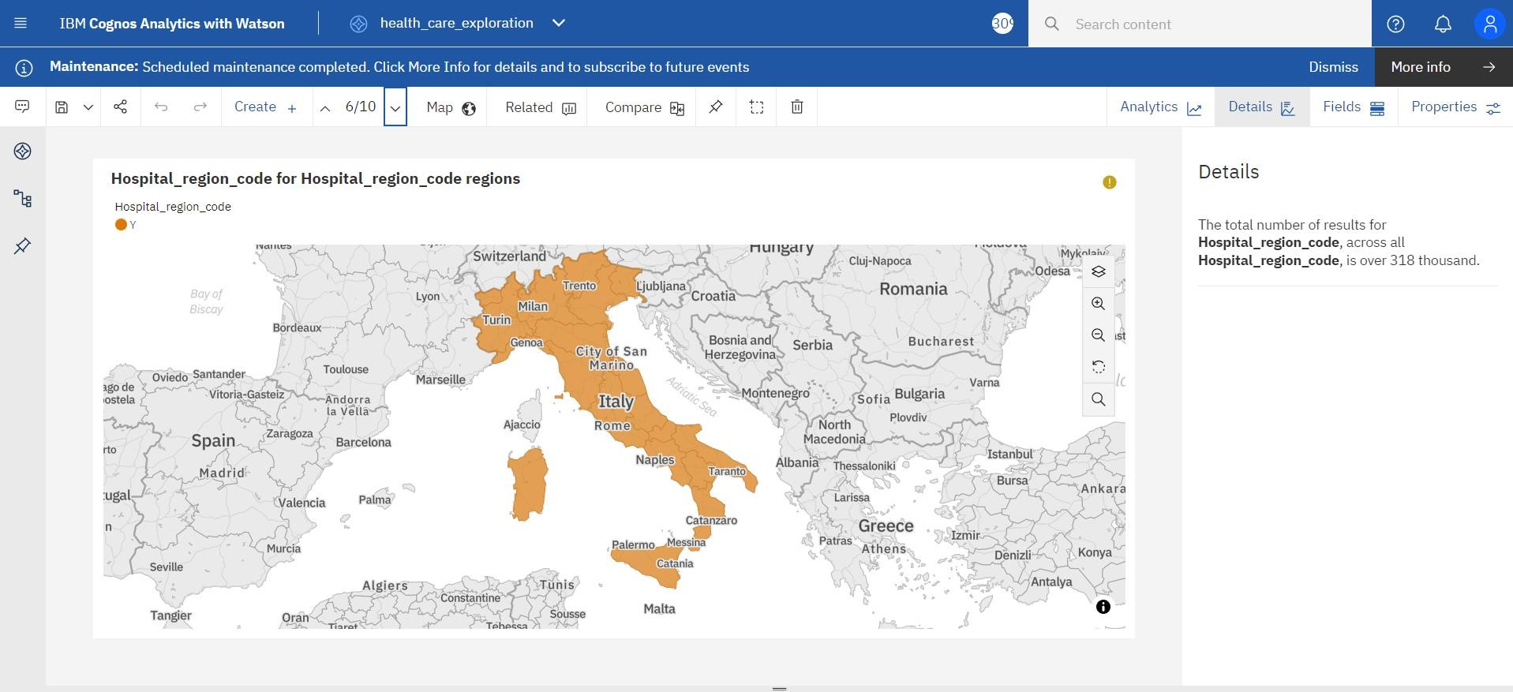

## City_Code_Hospital by City_Code_Hospital:

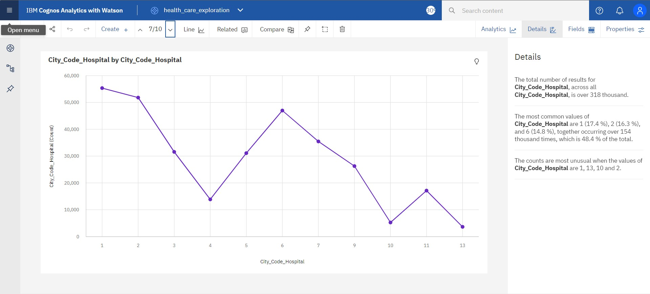

Type of Admission by Department colored by Department:

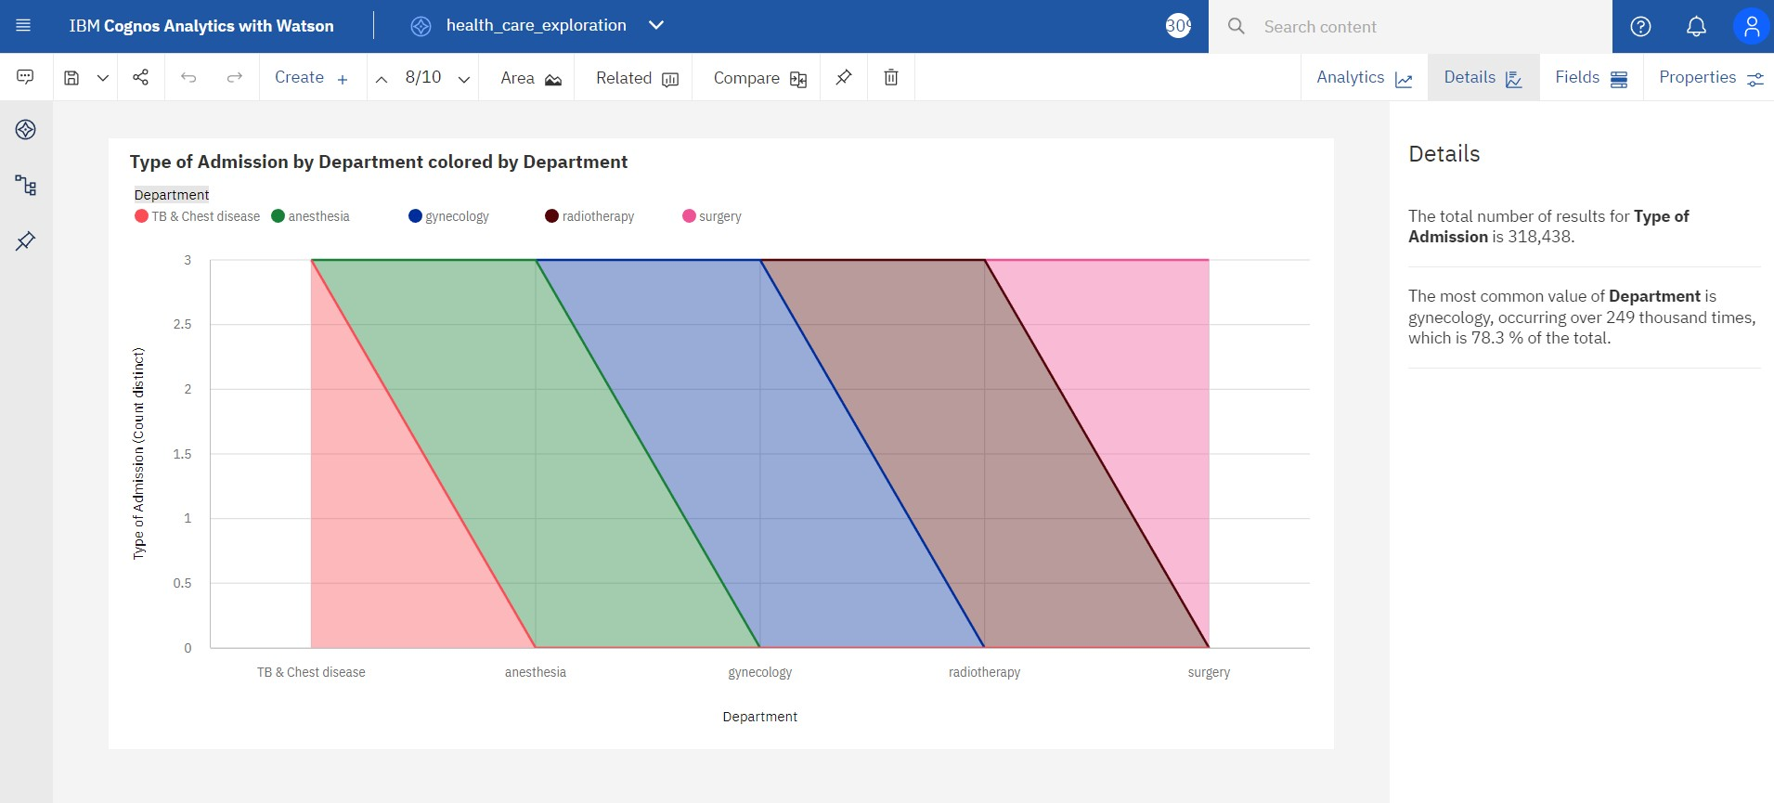

## City_Code_Hospital by Department:

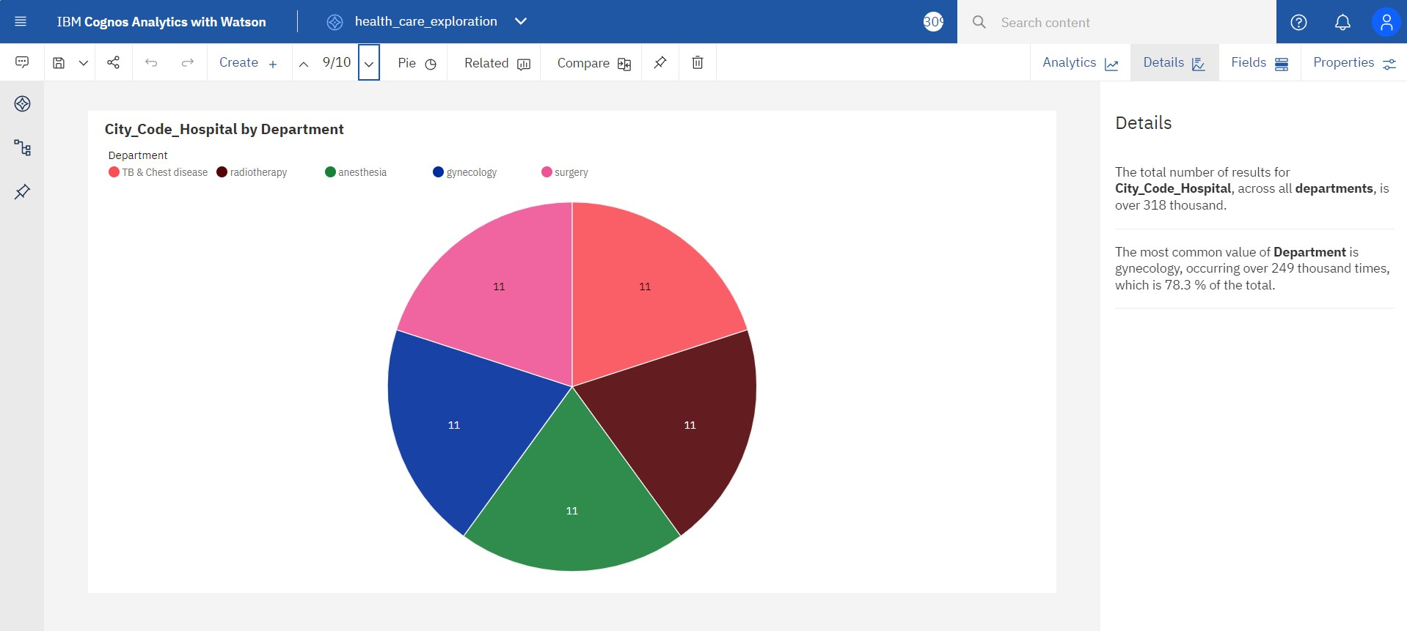

Ward_Type for Ward_Facility_Code:

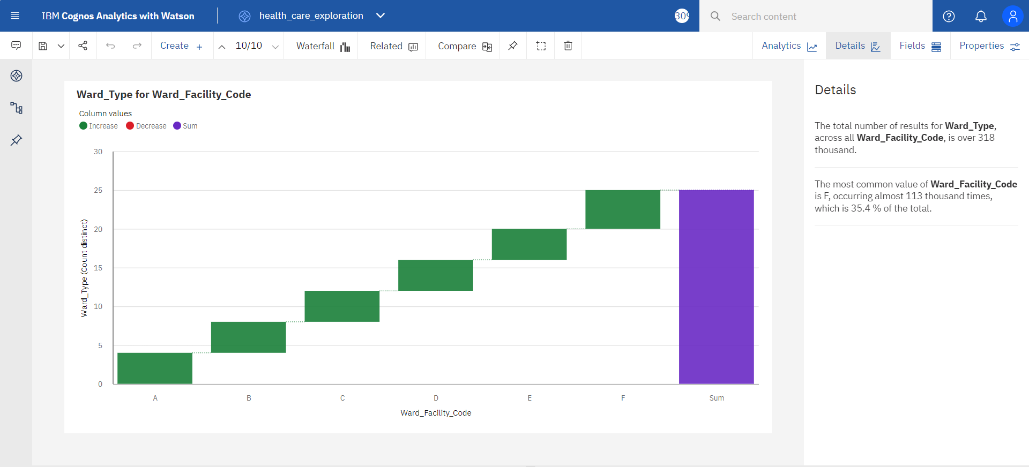

# Prepared data link :

https://us3.ca.analytics.ibm.com/bi/?perspective=ex plore&pathRef=.my_folders%2Fdata_exploration%2F health_care_exploration&subView=model000001844 10946c6_00000000